|  | Meeting Minutes |
| --- | --- |

# Call to order

A meeting of **Hi** memberswas held on **Facebook** at 19h00 everyday

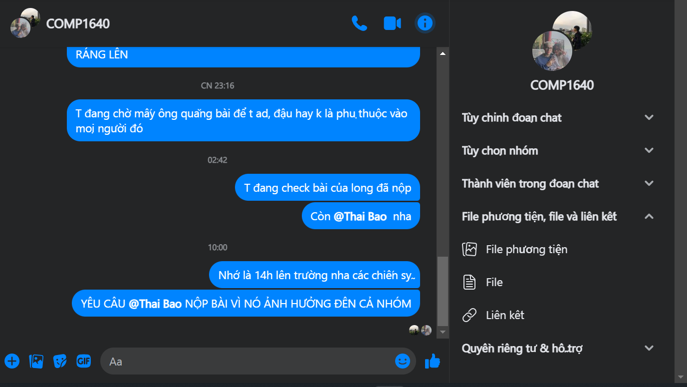

# Attendees

Attendees present included:

DO VU HUY – 001137369 – GCS17483

DANG NGOC THAI BAO – 001247262 -- GCS18215: Web Designer, Technical

TRAN KIM LONG – 001137511 -- GCS18044: Tester, Information architect

# Members not in attendance included:

**None**.

# Approval of minutes

Agreed (approved) by all members.